Topology Qualifying Examination, August 2015

Instructions
Work all problems. Give clear explanations and complete proofs.

Problems
- Show that if $A$ and $B$ are compact, then so is $A×B$.
- Given two points $a$ and $b$ of a space $S$, a collection of sets $A_{1},…,A_{n}$ in $S$ is called a simple chain from $a$ to $b$ if $a∈A_{1}$, $b∈A_{n}$, and $A_{i}∩A_{j}≠∅$ if and only if $|i-j|≤1$.
- Prove that if $\{U_{α}\}$ is a collection of open sets covering $S$ and $S$ is a connected space, then there is a simple chain of elements in $\{U_{α}\}$ joining $a$ and $b$ for any $a$ and $b$. Hint: Consider the set $C_{a}$ of all $b$ so that there is a simple chain of elements joining $a$ and $b$. Prove that $C_{a}$ is open and closed.
- Let $τ$ be the map that in cylindrical coordinates takes $(r,θ,z)$ to $(r,θ+π,z)$, thus $τ$ maps the torus $T$ to itself as shown below.
- 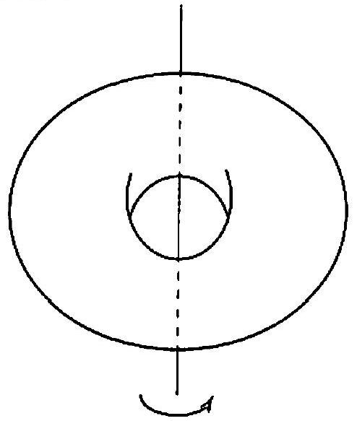
- The map $τ$ from the torus to itself.
  - Find a cell structure on $T$ such that $τ$ maps cells to cells.
  - Let $Q$ be the quotient of $T$ given by identifying $x$ and $τ(x)$ for all $x∈T$. What is $χ(Q)$?
  - Is $Q$ a surface?
- The nerve of a collection of sets is an abstract simplicial complex that has a 0-cell for each set, a 1-cell joining each pair of sets that intersect each other, a 2-cell for every triple of sets with a common intersection, and so forth. Consider the collection of sets below:
- 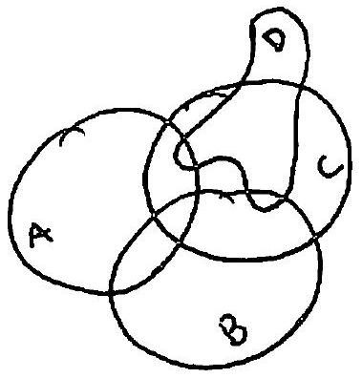
- Now
  - Draw the nerve of the collection.
  - Compute the homology of the nerve.
- A continuous vector field $V$ on the plane is a continuous map from $R^{2}$ to $R^{2}$. The portion of $V$ along the boundary of a disk $D$ is shown below:
- 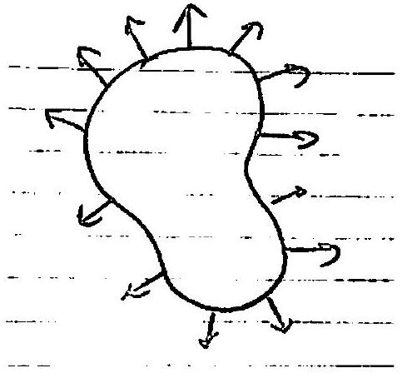
- Show that the vector field has a zero inside $D$.
- Express a Klein bottle as the union of two annuli. Use the Mayer-Vietoris sequence and this decomposition to compute its homology.
- Compute the fundamental group, using any technique you like, of $RP^{2}\#RP^{2}\#RP^{2}$.
- Explicitly give a collection of deck transformations on $\{(x,y)∣-1≤x≤1, -∞<y<∞\}$ such that the quotient is a Mobius band.

